MACHINE LEARNING - JAN 2026

Predicting High-Risk TTC Bus Delays for Neighbourhoods Across Toronto
Doris Chen, Maksym Golyuk, Arrujyan Muraleetharan, Taylor Strong, Michael Van Der Linden, Daniel Maciel

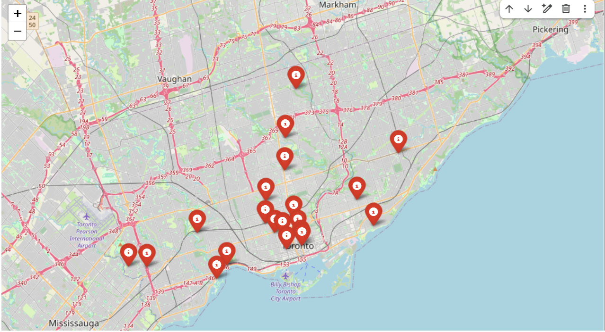

Introduction
Public transportation is essential for many Toronto residents, particularly for those who rely on the TTC as their primarily or only means of travel. Severe bus delays can disrupt daily life, increase commuter burdens, and create negative consequences for riders. The project will aim to provide riders a method to predict the level of risk for bus delays.

< more stuff >

Prior Work
<rouge can talk about the studies he found, and talk about how ours differs from those>

Predicting TTC Bus Delays
< problem statement >

Data Preparation
< doris talks about how the data was joined and problems encountered >

Data Exploration
< c & p stuff from the first half of group_project_predict.ipynb >

Initial Predictive Model
< c & p stuff from the second half of group_project_predict.ipynb >

Model Optimization

Hyperparameter Search
< c & p stuff from the second half of group_project_predict.ipynb >

Decreasing Dimensionality
< maxim’s stuff of fewer features >

Comparison of Different Training Models
< maxim’s stuff of fewer features >

Incorporating Weather Data
< taylor/michael weather stuff >

Conclusion
< summary >

